MORAY RUGBY FOOTBALL CLUB
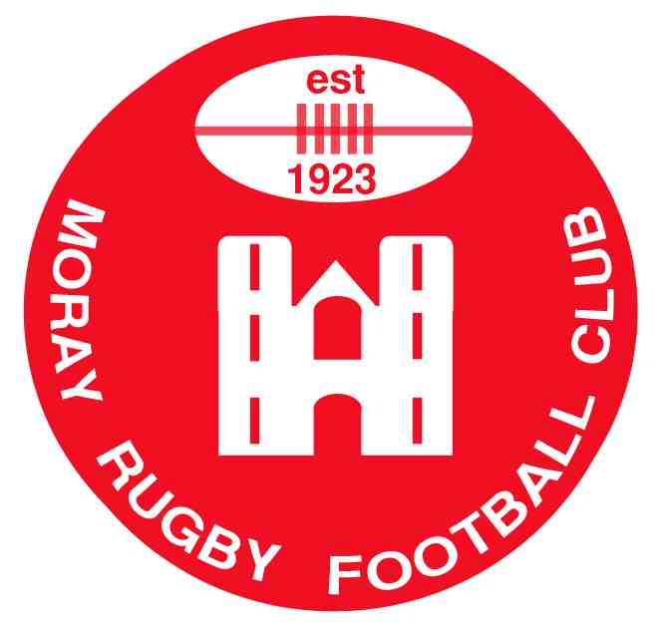
“LUCKY NUMBER” CLUB

The “Lucky Number Club” is looking for new members. For just £12 a year you can help make a valuable contribution to this fundraiser, which helps meet the cost of providing equipment etc. for all sections of the club.
In return for your £12 you will be allocated a “Lucky Number” and entered in 12 monthly draws. From the money collected 50% is given out in cash prizes and 50% put into the club funds.
The outlay is small and you could win a prize and at the same time be helping improve facilities for the members and the club as a whole.

If interested please complete the following and return to: -

Section A to: Johnny Morren, 30 Brechan Rig, Elgin, IV30 6FL
Section B to: YOUR BANK

MORAY RUGBY FOOTBALL CLUB “LUCKY NUMBER CLUB” MEMBERSHIP
SECTION A –

Name…………………………………………………………………………. Tel…………………………………………

Address…………………………………………………………………………………………………………………………

…………………………………………………Email……………………………………………………………………………

MORAY RUGBY FOOTBALL CLUB “LUCKY NUMBER CLUB” MEMBERSHIP
SECTION B –

Direct Debit – Moray Rugby Football Club: Please pay to The Royal Bank of Scotland, Elgin (83-20-06) for account of Moray Rugby Football Club 200 Club, Club account No. 00201981 the sum of £12 annually.

To commence on ……/……/20……, until cancelled by me in writing.

Signature…………………………………………………….. Bank…………………………………………….

Branch………………………………………… Account No……………………………………………………….

